Devops Project with CICD Pipeline

# Objective: - Deploy Java Code which contain Student Web App

Tools used: GitHub, Docker, Jenkins, Ansible

Step1: - I have used AWS free tier account to perform below tasks

* Create two EC2 Ubuntu Machines and configure parameter and allow 8080 Port for Jenkins.
* One machine will act as master node and second will act as Agent or worker node.
* While launching the machine create a new key pair or select existing one.

Step2:- Install Jenkins on one machine and this will act as master node.

* To Install Java “apt install openjdk-11-jdk-headless”
* To install Jenkins “<https://pkg.jenkins.io/debian-stable/>”
* To check Jenkins status “systemctl status Jenkins”
* To check public IP “curl ifconfig.io”
* To check Jenkins home page, use public IP of master node with port 8080
* Unlock Jenkins with password and get password from below location, “/var/lib/Jenkins/secrets/initialAdminPassword
* Select Install suggested Plugins
* Create one time credentials

Step3:- Login to Agent or worker node and perform below tasks

* To allow password Authentication and root login update file “/etc/ssh/sshd_config”
* Make this machine as agent because it will help to create pipeline and can be used to distribute load “login to Jenkins Server🡺New Node🡺Create Remote root Dir “/var/lib/jenkins”🡺Label🡺usage🡺Launch Method SSH
* Install tools like Java, maven, Docker, Ansible

Step4:- Integration of Jenkins with GitHub & Build

* Using GUI creating new project by “Chosen Freestyle Project”
* Source Code Management <https://github.com/juhi0589/HCL-Jenkins-Task.git>

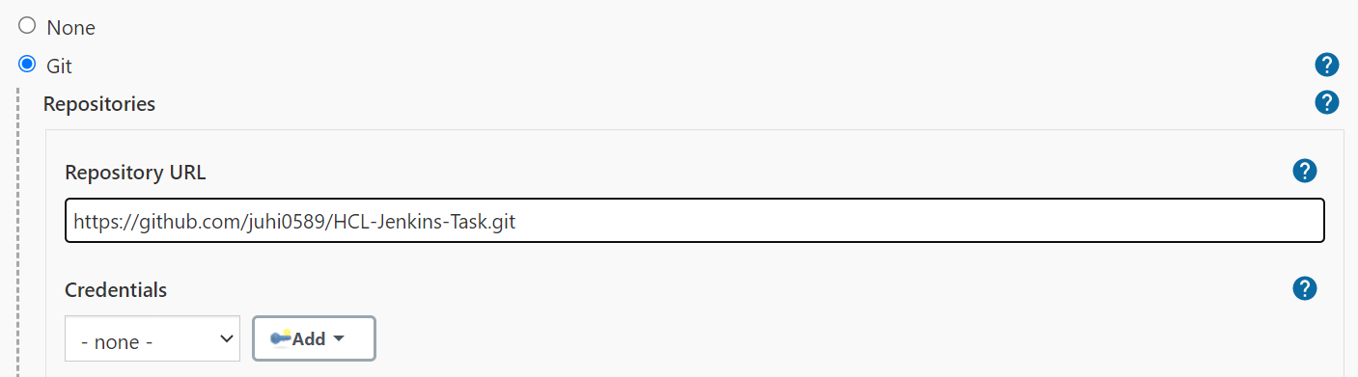

* I have use Maven as Build tool and select “Invoke top-level Maven targets”
* To verify I have performed “Build Now”

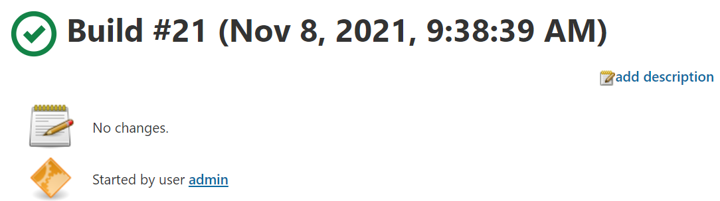

Step5:- Deployment of application as Docker container

* I have used Docker file to create an image.
* I have follow below steps to launch Docker container

“echo ${WORKSPACE}

ls -l ${WORKSPACE}/target/*.war

docker run -dit -p 8080:8080 -v ${WORKSPACE}/target/studentapp-2.5-SNAPSHOT.war:/usr/local/tomcat/webapps/server.war --name tomcat tomcat”

# 

# Different Stages for Pipelines

Stage 1: Clone from GitHub

Stage2: Create a Build

Stage3: Create an image

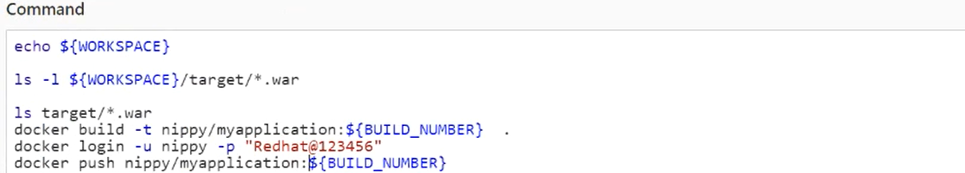

Stage4: Push an image to Docker Hub & Create a Container using image.

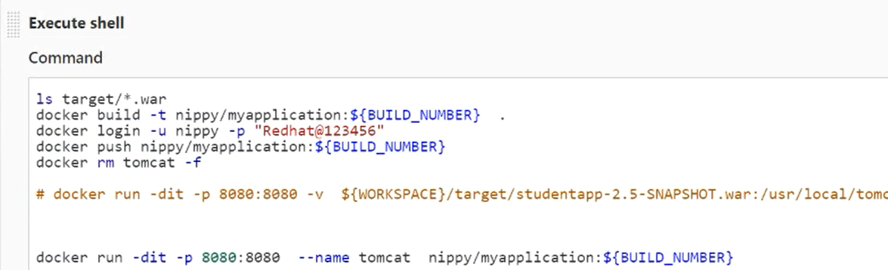

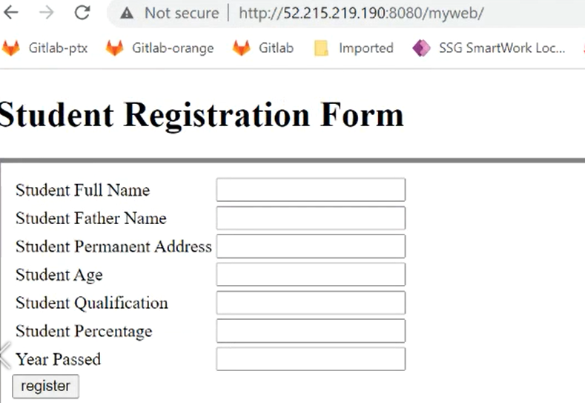

# I have also perform pipeline as a code and used visual studio code.

* Create new project and select “pipeline”

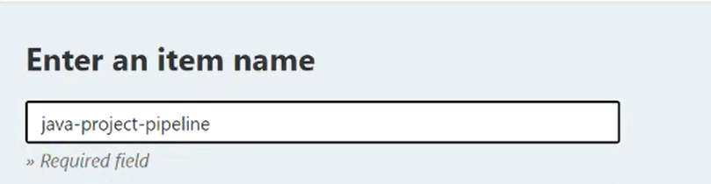

* Select Pipeline and create script which include different stages.

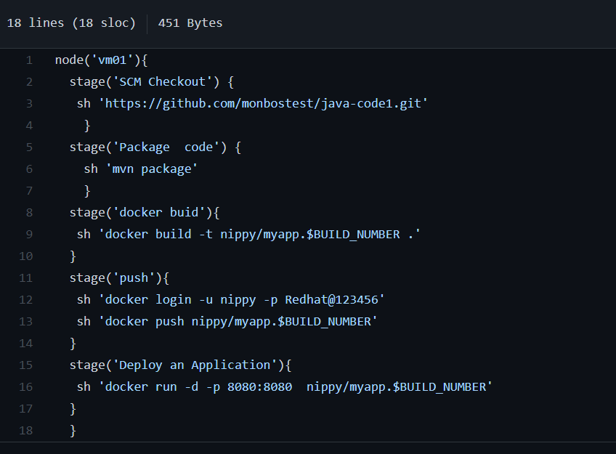

* Pipeline Stage View

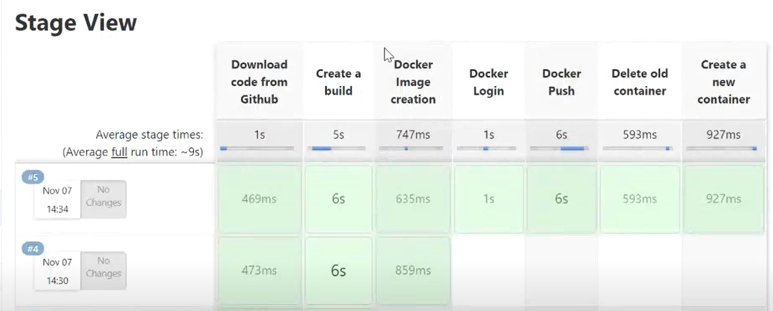

* Ansible Integration, for this Project I used Ansible to ping local host from Jenkins, however we can also use Ansible to configure nodes.
* Verify Ansible version using “ansible --version”
* Create connection by updating “/etc/ansible/hosts

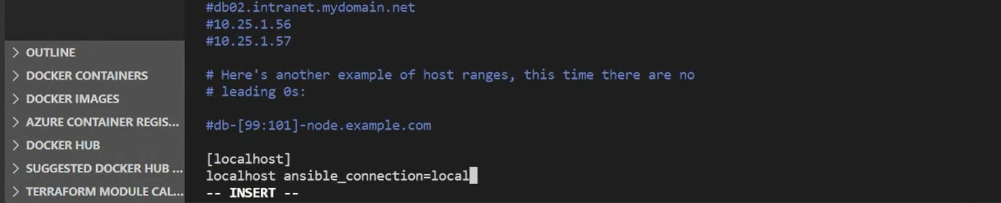

* First I try and ping local host using ansible “ansible localhost –m ping”

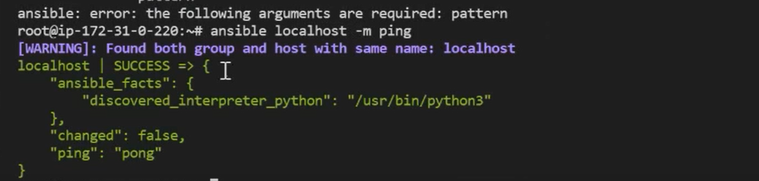

* Now I will run same command from Jenkins server

